**Don’t do it**

**Ha! Got ya!** Trying to run some *old school* ANOVAs *hum*? **I’ll show you even better!**

There is now a tremendous amount of data showing the inadequacy of ANOVAs as a statistical procedure ([Camilli, 1987](http://journals.sagepub.com/doi/abs/10.3102/10769986012001087); [Levy, 1978](https://www.tandfonline.com/doi/abs/10.1080/00949657808810247); [Vasey, 1987](https://onlinelibrary.wiley.com/doi/abs/10.1111/j.1469-8986.1987.tb00324.x); [Chang, 2009](https://link.springer.com/article/10.1007/s00180-009-0162-z)). Instead, many papers suggest moving toward the mixed-modelling framework ([Kristensen, 2004](https://www.physiology.org/doi/abs/10.1152/advan.00042.2003); [Jaeger, 2008](https://www.sciencedirect.com/science/article/pii/S0749596X07001337)), which was shown to be more flexible, accurate, powerful and suited for psychological data.

Using this framework, we will see how we can very simply answer our questions with R and the [psycho](https://github.com/neuropsychology/psycho.R) package.

**The Emotion Dataset**

Let’s take the example dataset included in the psycho package.

library(psycho)

library(tidyverse)

df <- psycho::emotion %>%

select(Participant_ID,

Participant_Sex,

Emotion_Condition,

Subjective_Valence,

Recall)

summary(df)

Participant_ID Participant_Sex Emotion_Condition Subjective_Valence

10S : 48 Female:720 Negative:456 Min. :-100.000

11S : 48 Male :192 Neutral :456 1st Qu.: -65.104

12S : 48 Median : -2.604

13S : 48 Mean : -18.900

14S : 48 3rd Qu.: 7.000

15S : 48 Max. : 100.000

(Other):624

Recall

Mode :logical

FALSE:600

TRUE :312

Our dataframe (called df) contains data from several participants, exposed to neutral and negative pictures (the Emotion_Condition column). Each row corresponds to a single trial. As there were 48 trials per participants, there are 48 rows by participant. During each trial, the participant had to rate its emotional valence (Subjective_Valence: positive - negative) experienced during the picture presentation. Moreover, 20min after this emotional rating task, the participant was asked to freely recall all the pictures he remembered.

Our dataframe contains, for each trial, 5 variables: the **name of the participant** (Participant_ID), its **sex** (Participant_Sex), the **emotion condition** (Emotion_Condition), the **valence rating** (Subjective_Valence) and whether the participant **recalled** the picture (Recall).

**The effect of Emotion**

Does the emotion condition modulate the subjective valence? How to answer?

**Whith a repeated measures ANOVA of course!**

Let’s run it:

summary(aov(Subjective_Valence ~ Emotion_Condition + Error(Participant_ID/Emotion_Condition), data=df))

Error: Participant_ID

Df Sum Sq Mean Sq F value Pr(>F)

Residuals 18 115474 6415

Error: Participant_ID:Emotion_Condition

Df Sum Sq Mean Sq F value Pr(>F)

Emotion_Condition 1 1278417 1278417 245.9 6.11e-12 ***

Residuals 18 93573 5198

---

Signif. codes: 0 '***' 0.001 '**' 0.01 '*' 0.05 '.' 0.1 ' ' 1

Error: Within

Df Sum Sq Mean Sq F value Pr(>F)

Residuals 874 935646 1070

Wow, we found that there is a significant effect of the emotional condition on valence ratings. *We might have Science material here.*

As you know, an ANOVA is pretty much a *condensed* linear model where the predictors are factors. Therefore, we can run an ANOVA on a linear mixed model (which includes the “error” term, or *random effect*).

library(lmerTest)

fit <- lmer(Subjective_Valence ~ Emotion_Condition + (1|Participant_ID), data=df)

anova(fit)

Type III Analysis of Variance Table with Satterthwaite's method

Sum Sq Mean Sq NumDF DenDF F value Pr(>F)

Emotion_Condition 1278417 1278417 1 892 1108 < 2.2e-16 ***

---

Signif. codes: 0 '***' 0.001 '**' 0.01 '*' 0.05 '.' 0.1 ' ' 1

As you can see, the results are, for the important bits (the sum of squares, mean square and *p* value), very close to those of the *traditional* approach.

Note that the psycho package, through the analyze function, also allows to display the interpretation of the underlying model itself with the following:

results <- analyze(fit)

print(results)

The overall model predicting Subjective_Valence (formula = Subjective_Valence ~ Emotion_Condition + (1 | Participant_ID)) successfully converged and explained 56.73% of the variance of the endogen (the conditional R2). The variance explained by the fixed effects was of 52.62% (the marginal R2) and the one explained by the random effects of 4.11%. The model's intercept is at -56.34 (SE = 2.88, 95% CI [-62.07, -50.61]). Within this model:

- The effect of Emotion_ConditionNeutral is significant (beta = 74.88, SE = 2.25, 95% CI [70.47, 79.29], t(892.00) = 33.29, p < .001***) and can be considered as medium (std. beta = 0.73, std. SE = 0.022).

**Post-hoc / Contrast Analysis**

Then, we wou’d like to see how the levels are different. To do this, we have to run a “contrast” analysis, comparing the estimated means of each level.

# We have to provide the model (here called fit and the factors we want to contrast

results <- get_contrasts(fit, "Emotion_Condition")

print(results$contrasts)

| **Contrast** | **Difference** | **SE** | **df** | **t.ratio** | **p.value** |
| --- | --- | --- | --- | --- | --- |
| Negative - Neutral | -74.88 | 2.25 | 892 | -33.29 | 0 |

It appears that the negative condition yields a significantly lower valence (*i.e.*, more negative) than the neutral (-74.88 points of difference). At this point, we usually also want to know the means of each conditions. However, we often do it by directly computing the means and SDs of our observed data. But that’s not the cleanest way, as our data might be unbalanced or biased.

The best way to do it is to estimate means based on the fitted model (marginal means). Those were automatically computed when running the get_contrasts function. We just have to extract them.

| **Emotion_Condition** | **Mean** | **SE** | **df** | **CI_lower** | **CI_higher** |
| --- | --- | --- | --- | --- | --- |
| Negative | -56.34 | 2.88 | 25.04 | -62.27 | -50.41 |
| Neutral | 18.54 | 2.88 | 25.04 | 12.61 | 24.47 |

Finally, we can plot these means:

library(ggplot2)

ggplot(results$means, aes(x=Emotion_Condition, y=Mean, group=1)) +

geom_line() +

geom_pointrange(aes(ymin=CI_lower, ymax=CI_higher)) +

ylab("Subjective Valence") +

xlab("Emotion Condition") +

theme_bw()

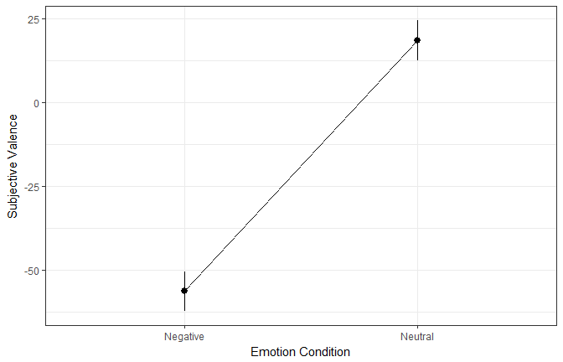

**Interaction**

Let’s repeat the previous steps with adding the participant’s **sex** as a predictor.

fit <- lmer(Subjective_Valence ~ Emotion_Condition * Participant_Sex + (1|Participant_ID), data=emotion)

anova(fit)

Type III Analysis of Variance Table with Satterthwaite's method

Sum Sq Mean Sq NumDF DenDF F value

Emotion_Condition 703963 703963 1 891 621.8068

Participant_Sex 520 520 1 17 0.4593

Emotion_Condition:Participant_Sex 20496 20496 1 891 18.1041

Pr(>F)

Emotion_Condition < 2.2e-16 ***

Participant_Sex 0.5071

Emotion_Condition:Participant_Sex 2.313e-05 ***

---

Signif. codes: 0 '***' 0.001 '**' 0.01 '*' 0.05 '.' 0.1 ' ' 1

It seems that there is a significant main effect of the emotion condition, as well as an interaction with the participants’ sex. Let’s plot the estimated means.

estimated_means <- get_means(fit, "Emotion_Condition * Participant_Sex")

estimated_means

| **Emotion_Condition** | **Participant_Sex** | **Mean** | **SE** | **df** | **CI_lower** | **CI_higher** |
| --- | --- | --- | --- | --- | --- | --- |
| Negative | Female | -59.73 | 3.28 | 23.3 | -66.51 | -52.95 |
| Neutral | Female | 20.05 | 3.28 | 23.3 | 13.27 | 26.83 |
| Negative | Male | -43.63 | 6.35 | 23.3 | -56.76 | -30.50 |
| Neutral | Male | 12.89 | 6.35 | 23.3 | -0.24 | 26.02 |

ggplot(estimated_means, aes(x=Emotion_Condition, y=Mean, color=Participant_Sex, group=Participant_Sex)) +

geom_line(position = position_dodge(.3)) +

geom_pointrange(aes(ymin=CI_lower, ymax=CI_higher),

position = position_dodge(.3)) +

ylab("Subjective Valence") +

xlab("Emotion Condition") +

theme_bw()

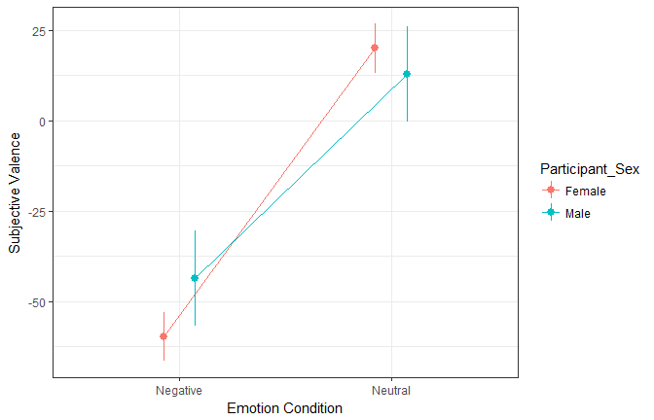

Let’s investigate the contrasts:

get_contrasts(fit, "Emotion_Condition * Participant_Sex")

| **Contrast** | **Difference** | **SE** | **df** | **t.ratio** | **p.value** |
| --- | --- | --- | --- | --- | --- |
| Negative,Female - Neutral,Female | -79.78 | 2.51 | 891.0 | -31.81 | 0.00 |
| Negative,Female - Negative,Male | -16.10 | 7.15 | 23.3 | -2.25 | 0.14 |
| Negative,Female - Neutral,Male | -72.62 | 7.15 | 23.3 | -10.16 | 0.00 |
| Neutral,Female - Negative,Male | 63.67 | 7.15 | 23.3 | 8.91 | 0.00 |
| Neutral,Female - Neutral,Male | 7.15 | 7.15 | 23.3 | 1.00 | 0.75 |
| Negative,Male - Neutral,Male | -56.52 | 4.86 | 891.0 | -11.64 | 0.00 |

It appears that the differences between men and women is not significant. However, by default, get_contrasts uses the Tukey method for p value adjustment. We can, with an exploratory mindset, **turn off the p value correction** (or choose other methods such as *bonferonni*, *fdr* and such).

get_contrasts(fit, "Emotion_Condition * Participant_Sex", adjust = "none")

| **Contrast** | **Difference** | **SE** | **df** | **t.ratio** | **p.value** |
| --- | --- | --- | --- | --- | --- |
| Negative,Female - Neutral,Female | -79.78 | 2.51 | 891.0 | -31.81 | 0.00 |
| Negative,Female - Negative,Male | -16.10 | 7.15 | 23.3 | -2.25 | 0.03 |
| Negative,Female - Neutral,Male | -72.62 | 7.15 | 23.3 | -10.16 | 0.00 |
| Neutral,Female - Negative,Male | 63.67 | 7.15 | 23.3 | 8.91 | 0.00 |
| Neutral,Female - Neutral,Male | 7.15 | 7.15 | 23.3 | 1.00 | 0.33 |
| Negative,Male - Neutral,Male | -56.52 | 4.86 | 891.0 | -11.64 | 0.00 |

Without correcting for multiple comparisons, we observe that men rate the negative pictures as significantly less negative than women.

**Credits**

This package helped you? Don’t forget to cite the various packages you used :)